**

*Shivansh Mishra*

*Detecting the speed of the vehicle and distance covered by it using the GPS Module*

***Apparatus Used* –**

1. Arduino UNO
2. Neo 6M GPS Module

What is the GPS module?

It’s a kind of the sensor that connects itself with the satellite and return you the latitude and longitude of your position.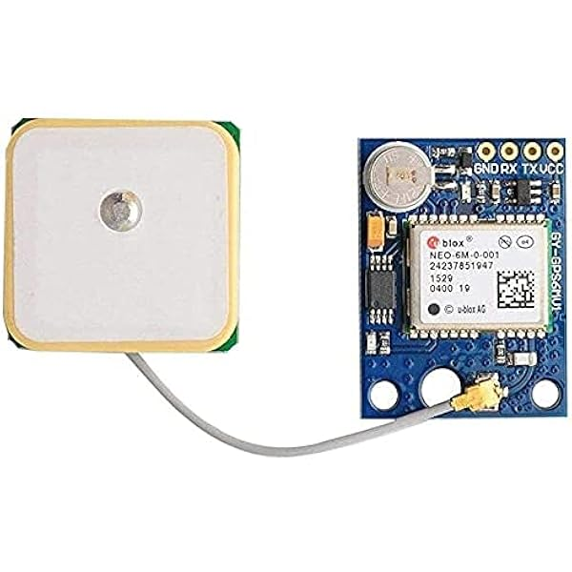

***Basic principle behind it—***

It uses the doppler effect, which is based on the calculating the relative speed of two objects.

How does it can be used to measure the distances and the speed of the any object?

**Main Ideas—**

1. When the module is connected to the satellite then it send the NEMA sentences through the UART communication to the microcontroller (Arduino).
2. NEMA sentences has the information like the latitude, longitude, altitude, speed and time etc.
3. Now using the prebuilt libraries of the Arduino uno (Neo++.h) we can decode the NEMA sentences according to our requirements.

My code of the Arduino—

#include <TinyGPS++.h>

#include <SoftwareSerial.h>

TinyGPSPlus gps;

SoftwareSerial ss(3, 4); // RX, TX

void setup() {

Serial.begin(9600);

ss.begin(9600);

Serial.println("GPS Speed Test");

}

void loop() {

while (ss.available() > 0) {

if (gps.encode(ss.read())) {

if (gps.location.isUpdated()){

Serial.print("Lattitude: ");

Serial.print(gps.location.lat(),6);

}

if (gps.speed.isValid()) {

// Speed in km/h

Serial.print("Speed: ");

Serial.print(gps.speed.kmph());

Serial.println(" km/h");

}

}

}

}

Limitations of this method –

1. This method of measuring the speed is dependent on the satellite connection so doesn’t get the precise information .
2. This method is highly affected by the weather conditions.
3. Satellite data can be inaccurate in the specific places like jungles and mountains and other places like the google map.

Problem – Unfortunately, in our team “Averera” we had only one GPS module and it was not working properly. So I stopped there but learned the basics behind that.